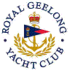 | Royal Geelong Yacht Club Inc.  Est 1859
Trophy Deed of Gift.

Trophy: | Kings Cup
Presented by: | King family
Date: | 1990
For: | TBA… Thunderbird Fleet
Remarks / Revisions
Click here for a List of Recipients

